JECRC
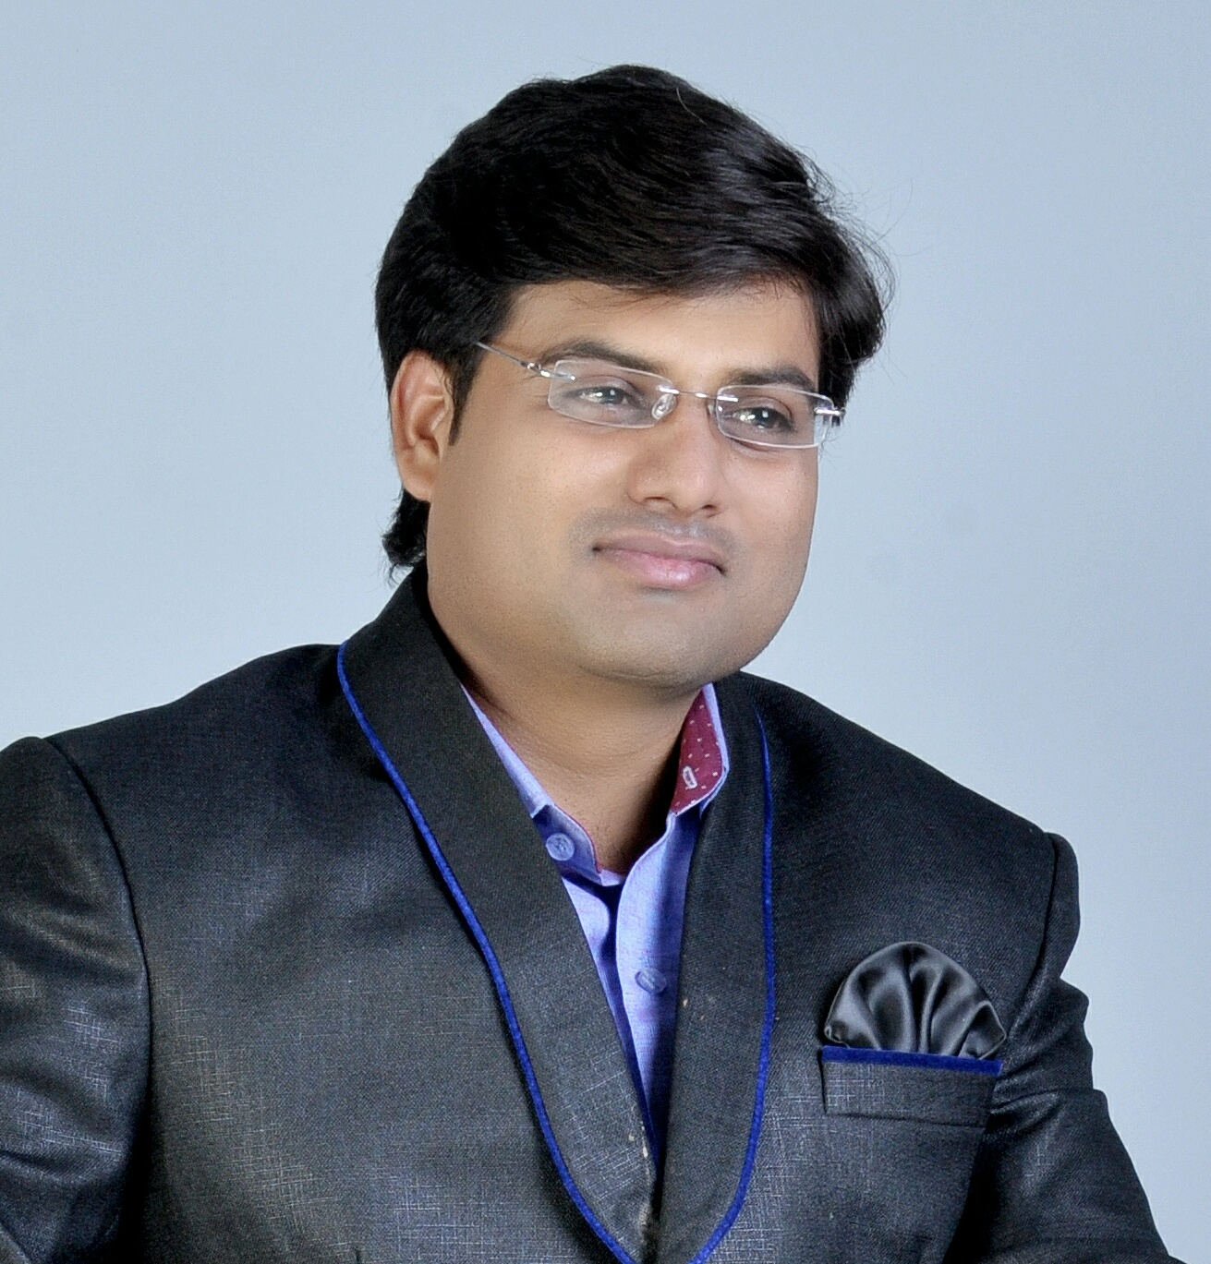Affix and Attest
passport
size otograph
JAIPUR

INDIVIDUAL FACULTY DATA SHEET
Name of the faculty member | : | Nitin chhabra
Present Designation | : | Faculty
Email Id : nitinchhabra.me@jecrc.ac.in
Contact Details : 114,Adarsh Nagar,Malpura(Tonk)Rajasthan

I. Particulars of Educational Qualification: (only completed)

Category | Name of the Degree | Specialization | Year of Passing | Name of the College | Name of the University
UG | B E | MECHANICAL | 2009 | JECRC JAIPUR | UOR, Jaipur
PG
Ph.D.

II. Academic Experience : 6 Years

III. Industrial Experience :3 Years

IV. Title of Ph.D. Thesis :

V. Awards/Achievements :

VI. Research/Specialization : Mechanical Engineering

VII. Course Taught : ENGINEERING MECHANICS, Reliability and maintenance engineering

VIII. Refereed International Journal Publication :

IX. International Conference Proceeding :

X. Books Written :

XI. M.Tech Thesis Guide :

XII. PHD Thesis Guide :

XIII. Professional Body Membership :

